MBA 546 Case Report, Week 3
Topic: Escape Rooms
Due date: 17 September 2023
Submitted by Samyak Pratap Shah
Escape Rooms

Executive Summary
In response to the competitive entertainment market, our company launched a significant project last year, introducing three engaging themes (Halloween, Jailbreak, and Cyberpunk) across our 24 escape room locations in Ohio and Pennsylvania. Alongside theme innovation, we also experimented with two primary advertising methods: billboards and social media. This led to six distinct location categories based on theme and advertising. Our primary goal in this case report is to assess the resonance of themes with our audience and evaluate the effectiveness of advertising channels in driving sales. Through statistical analyses, encompassing numerical and graphical summaries, two-way ANOVA, and post-hoc tests, this report provides actionable insights for optimizing themes and advertising strategies, ensuring maximum impact in a fiercely competitive market.
The analysis variables, specifically sales figures, are detailed in the provided table, covering different themes (Cyberpunk, Halloween, Jailbreak) and advertising methods (Billboard/social media) in thousands of dollars. Notably, Cyberpunk exhibits the lowest average sales, followed by Jailbreak and Halloween. Conversely, Halloween on Billboard and Jailbreak on social media yield the highest sales. Significant differences in sales figures are apparent when comparing Billboard and Social Media options, with variances of 90 for Cyberpunk, 89.75 for Halloween, and 135.75 for Jailbreak.
While these initial summary statistics offer insights, the need for further investigation is evident. Our analysis seeks to ascertain if there's a consistent effect of advertising and theme choices on sales. The statistical evaluation includes one-way ANOVA, with a significant p-value of 0.0036, suggesting differences across combinations. Additionally, the influence of advertising and theme on sales is examined, with p-values of 0.0020 for advertising and 0.0079 for theme, indicating their significant impact.
In summary, this comprehensive analysis empowers us to make strategic recommendations. We advise prioritizing social media as the primary advertising method due to its consistently higher sales impact. Furthermore, we recommend allocating resources towards promoting Halloween and Jailbreak themes, both demonstrating strong sales potential, while considering a measured approach to the Cyberpunk theme, given its lower sales performance. These insights will guide our future strategic decisions in the competitive entertainment market.

Introduction
My company embarked on an ambitious project last year, introducing three captivating themes (Halloween, Jailbreak, and Cyberpunk) across our 24 escape room locations in Ohio and Pennsylvania. To enhance sales, we experimented with two primary advertising channels: billboards and social media. These combinations resulted in six categories for our locations. The primary objective of this case report is to determine which themes resonated most with our audience and whether one advertising method proved more effective in boosting sales. Using statistical analyses, including numerical and graphical summaries, two-way ANOVA, and post-hoc tests, this report offers actionable insights to inform our future strategic decisions, optimizing both themes and advertising strategies for maximum impact in a highly competitive market.

Data
Analysis Variable: Sales Sales
Advertising | Theme | No. of Obs | Mean
Billboard | Cyberpunk | 4 | 472.75
 | Halloween | 4 | 571
 | Jailbreak | 4 | 569.5
Social Media | Cyberpunk | 4 | 562.75
 | Halloween | 4 | 660.75
 | Jailbreak | 4 | 705.25
The table above displays analysis variables, specifically sales figures, for different themes (Cyberpunk, Halloween, Jailbreak) and advertising methods (Billboard/social media), all in thousands of dollars. Cyberpunk has the lowest average sales (472.75 on Billboard and 562.75 on social media), followed by Jailbreak (569.5 on Billboard) and Halloween (660.75 on social media). Conversely, Halloween on Billboard (571 on average) and Jailbreak on social media (705.25 on average) have the highest sales.

The variance in sales between selecting the billboard option and opting for social media is 90 for Cyberpunk, 89.75 for Halloween, and 135.75 for Jailbreak.
While these summary statistics provide initial insights, they offer only a glimpse of what further analysis may reveal. This analysis will help us determine if there is an interaction in the data and whether the choice of advertisement has consistent effects across themes. The sales differences vary among themes, indicating the need for additional investigation to make an informed decision.

Analysis
During the initial stage, I approached the A NOVA analysis, considering six distinct factors within each of the combinations.
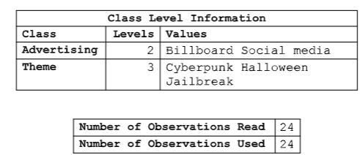
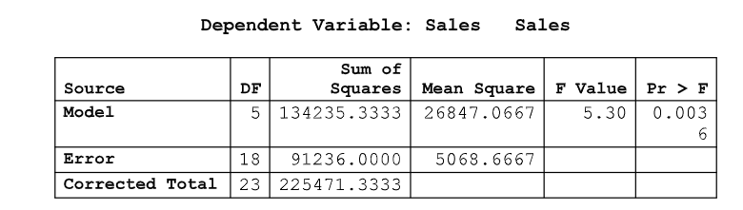
From the above table, if we cannot dismiss the null hypothesis, indicating no significant difference among the combinations, we would halt the analysis and state that it appears none of the advertising choices or themes are impacting sales. However, as the p-value is 0.0036, which is below the 5% threshold of 0.05, we can conclude there is a significant difference across the combinations.
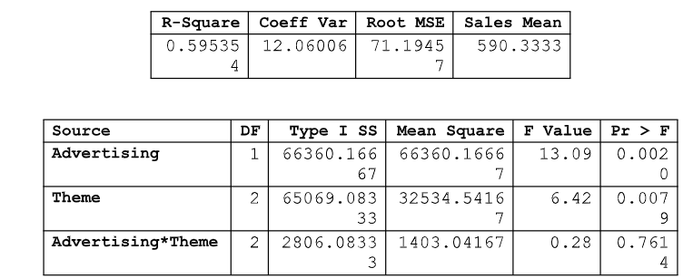
Moving forward, we need to assess whether each of the factors influences the dependent variable (sales). To do this, we examined individual rows in the Analysis of Variance table. In the advertising row, the p-value is 0.0020, lower than the 5% threshold, leading us to reject the null hypothesis and conclude that advertising affects sales.
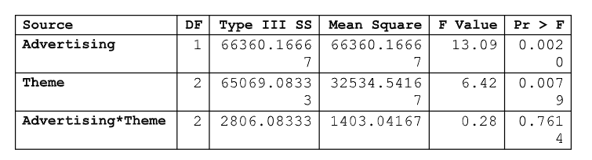
Similarly, in the above table, in the theme row, the p-value of 0.0079 is considerably smaller than our 5% threshold. Consequently, we reject the null hypothesis, indicating that the choice of themes does indeed impact sales.
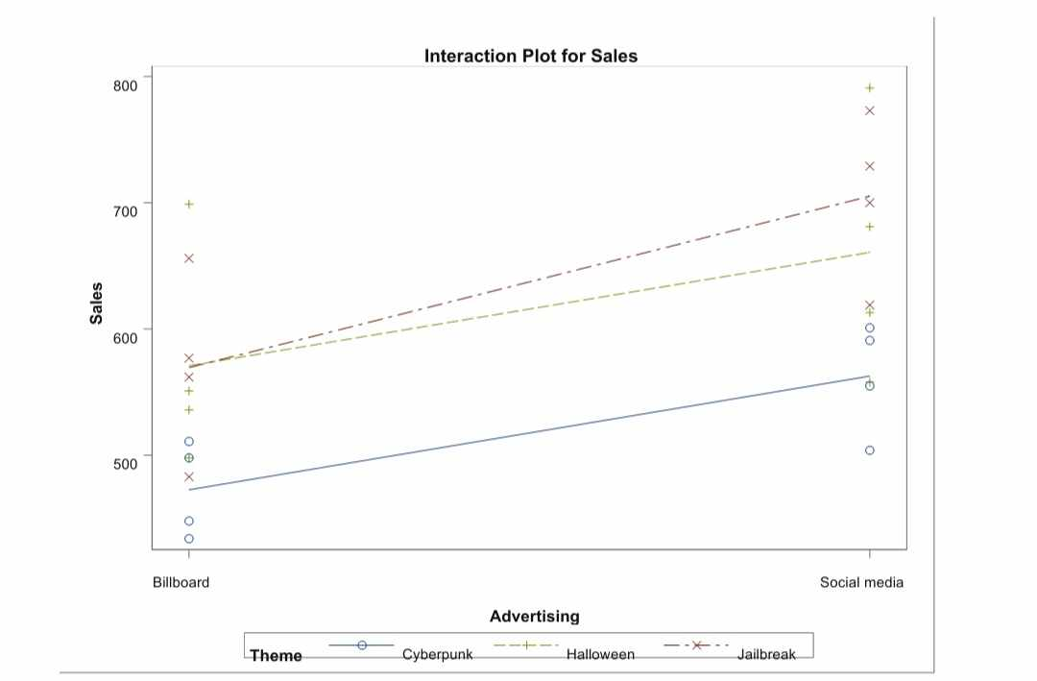
THE INTERACTION PLOT GRAPH
The graph provides a visual representation of the mean values for different groups. It's evident from the graph that there is an interaction between the means of Halloween and Jailbreak at the billboard area. This interaction is apparent because the lines intersect at the billboard area and then diverge at the social media area. This pattern aligns with the data, which also showed a small difference in means between Halloween and Jailbreak themes on the billboard (571 and 569, respectively, in thousands of dollars).
However, the situation varies when it comes to the Cyberpunk theme. The graph clearly depicts a substantial disparity in means, which aligns with the data. Specifically, the difference in means between the Cyberpunk theme and Halloween is notably large, exceeding 98.25 and 97.25 when compared to the Jailbreak theme.
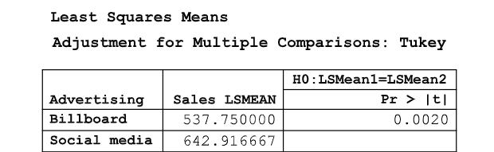
In the subsequent analysis, we aimed to assess the impact of different advertising types and themes on sales. Referring to the Least Squares Mean, Adjustment for Multiple Comparisons, and Tukey table above, it's evident that the p-value remains at 0.0020, which is less than the 5% threshold.
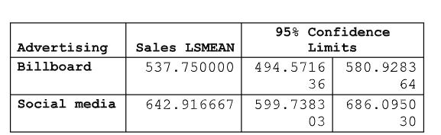
Examining the table that compares billboard sales to social media sales, it's apparent that social media outperformed billboards in terms of generating sales.
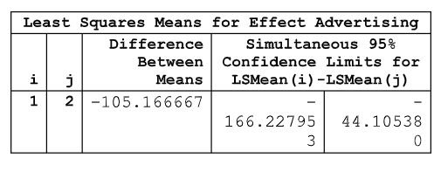

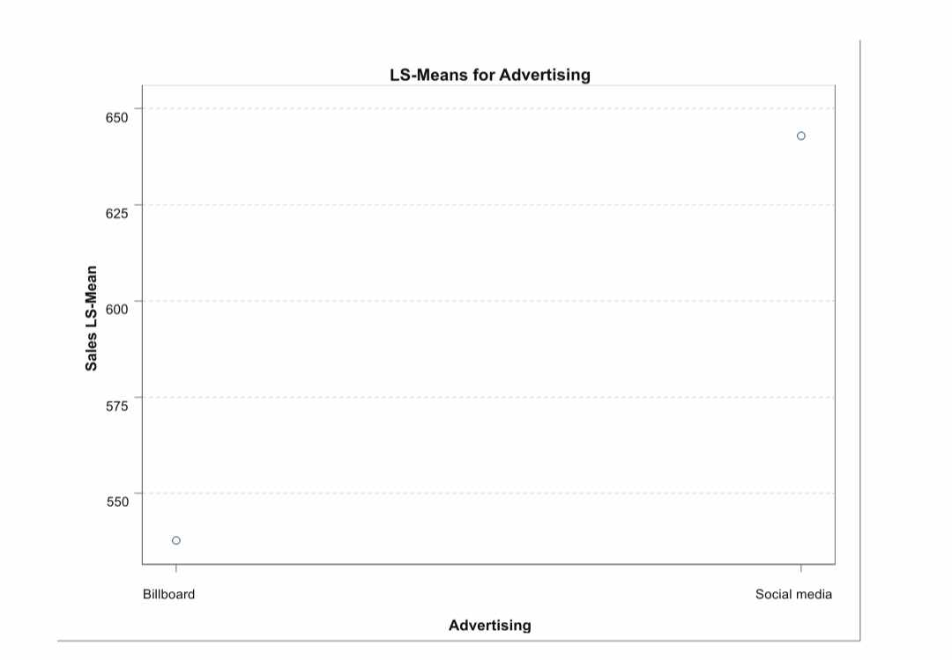
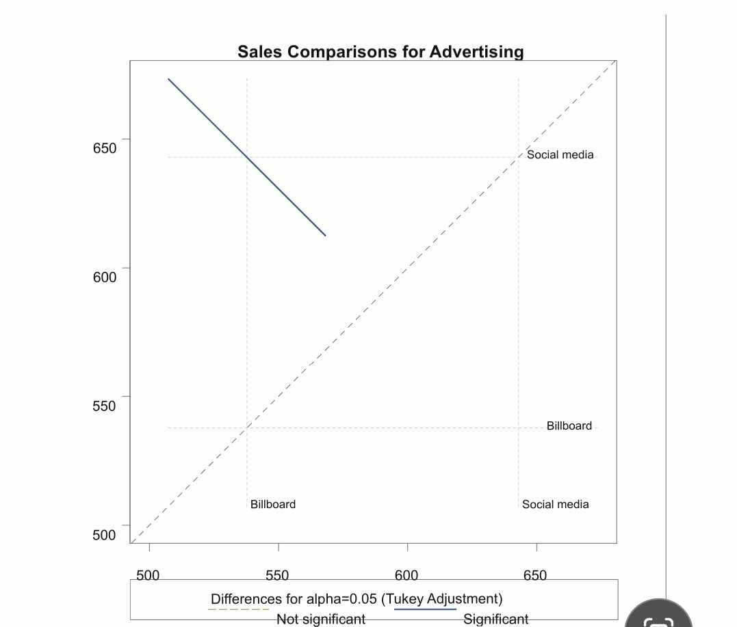
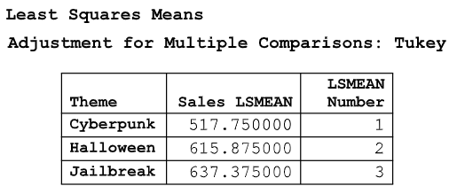
In this table, we observe substantial gaps between the sales means of different themes (Cyberpunk, Halloween, and Jailbreak). Notably, there's a considerable difference between Cyberpunk and Halloween, as well as between Cyberpunk and Jailbreak. However, the difference between Halloween and the Jailbreak theme is relatively small.
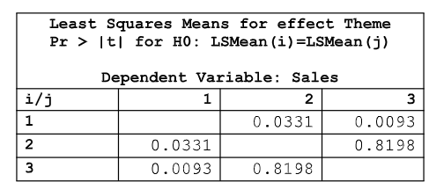
The p-values for Cyberpunk vs. Halloween (2 vs. 1) and Jailbreak vs. Cyberpunk (3 vs. 1) are below the 0.05 threshold, indicating significant differences in sales figures. Jailbreak has higher sales compared to Cyberpunk. However, the p-value for Halloween vs. Jailbreak (2 vs. 3) is higher than the threshold, suggesting no significant evidence of a difference in sales figures between these themes.
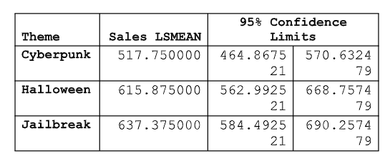
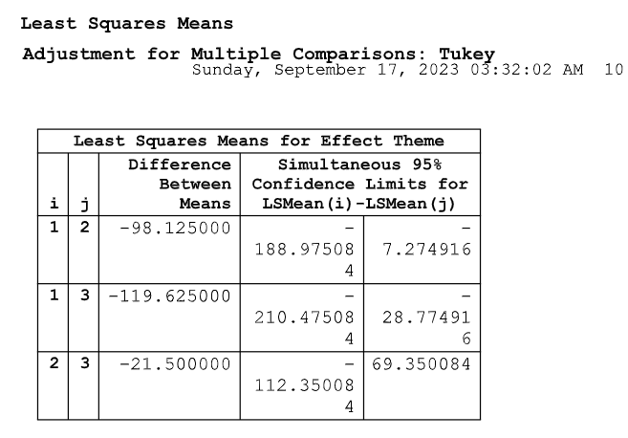
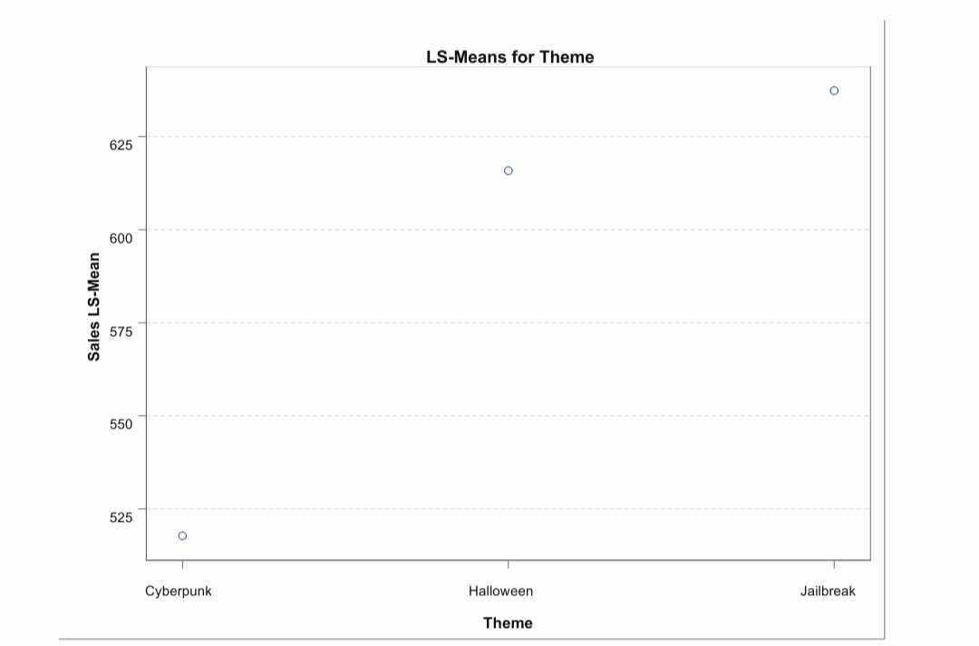

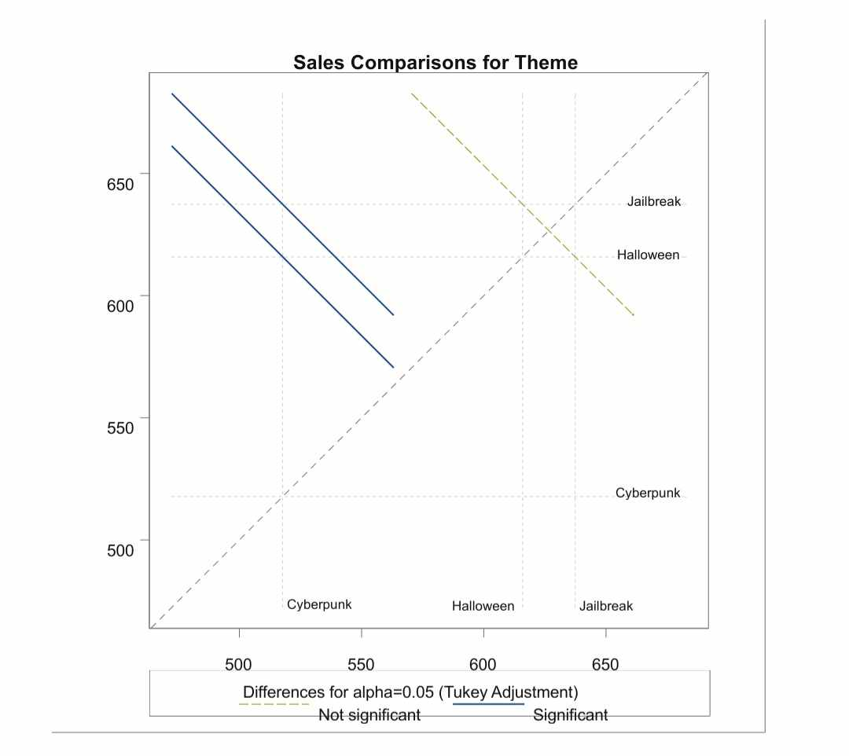

Conclusions/Recommendations
Based on the insights derived from my analysis, I would advise the escape room company to prioritize the utilization of social media as their primary advertising method, rather than relying extensively on billboards. The data clearly indicates that conducting advertising through social media results in higher sales.
In terms of themes, it is evident that the company should allocate more resources towards promoting the Halloween and Jailbreak themes. Both themes have consistently generated above-average sales and have demonstrated similar revenue potential. Conversely, allocating excessive resources to the Cyberpunk theme would be counterproductive, as it has thus far yielded the lowest sales figures.

